Requirements for this paper:

 | Multiple-choice cards: | N |  | Non-programmable calculator: | Y |  |  |  | Open book examination? | N
 | Graph paper: | N |  | Laptop: | Y

EXAMINATION: | Semester TEST 2024 | PROGRAMME: | RBM601
MODULE CODE: | MBAC51212/MRFM51024 | DURATION: | 2 HOURs
MODULE DESCRIPTION: | Basic Accounting 1B | MARKS: | 100
EXAMINER(S): | T PRETORIUS | DATE: | 5 Nov 2024
MODERATOR | Internal Moderator: K Kaelo  External Moderator: Mr TN Toolo

Question 1 (30)

Use the information below in the books of Mocha Coffee Shop. Show all working details and give your answers to the first decimal place only. The business obtains a profit mark-up of 65%.
REQUIREMENT: Use the table below to answer the questions:

Ratio | Formula | 2022 | 2021 | Comment

1.1 Calculate the following for the year 2022 and 2021:
REQUIRED:
1.1.1 Gross profit as a percentage on cost of sales (4)
1.1.2 Net profit as a percentage of turnover (3)
1.1.3 Current ratio (4)
1.1.4 Acid test ratio (4)
1.1.5 Return on average owner’s equity (5)
1.2 Do you think Mocha Coffee Shop can be satisfied with the gross profit % on cost of sales? Comment and quote figures to support your answer (3)
1.3 Comment on the liquidity of Mocha Coffee Shop.
Quote TWO financial indicators with figures to support your answer (4)
1.4 Should Mocha Coffee Shop be satisfied with the returns on average owner’s equity? Comment by quoting figures to support your answer (3)
RETURN on Owners Equity 2021 is 39%
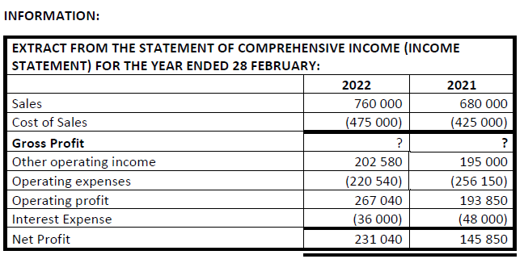
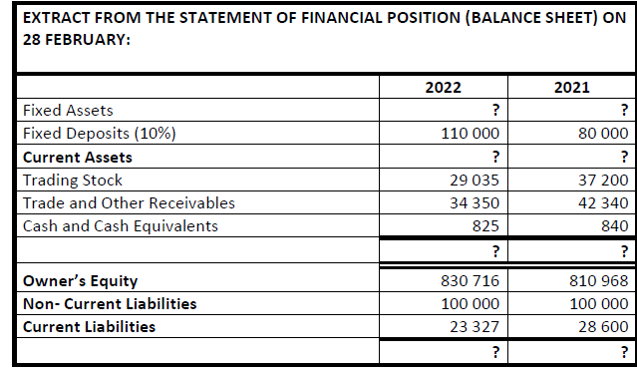

Question 2 (14)

REQUIREMENT: Write the letter and the answer in your answer book ex A R20

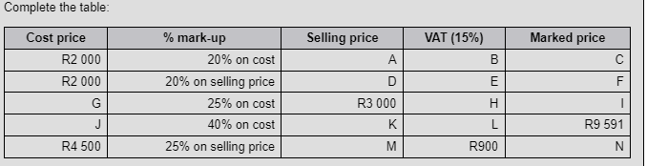
(14)

Question 3 (27)
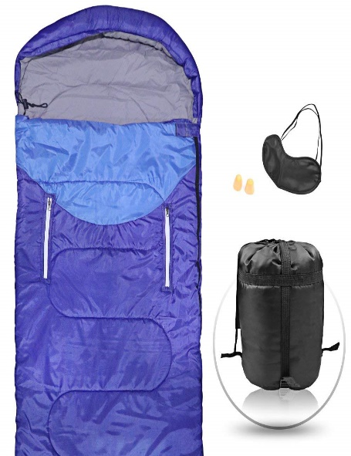
This Photo by Unknown Author is licensed under CC BY

REQUIREMENT: Write the question number and the answer ex 3.1 b

Campers Ltd sells sleeping bags. The selling price of each sleeping bag is R145. Variable costs are R105 per sleeping bag, and the total fixed costs are R330 000 per month. At present, the company sells 8 000 sleeping bags per month.

3.1 The contribution per sleeping bag is:
A R40
B R45
C R50
D R55
3.2 How many sleeping bags would have to be sold to break even?
A 8 500
B 8 250
C 8 520
D 8 502
3.3 The breakeven point in rands is:
A R1 960 250
B R1 169 250
C R1 196 250
D R1 691 250
3.4 How many sleeping bags would have to be sold to earn a minimum profit of R8 000 per month?
A 8 500
B 8 540
C 8 405
D 8 450
3.5 The margin of safety ratio is:
A (3,13%)
B 3,13%
C 3,31%
D (3,31%)
3.6 The net profit or loss under the present operating conditions is:
A loss of R20 000
B loss of R10 000
C profit of R20 000
D profit of R10 000

In an attempt to improve profitability, the company has investigated the impact of three independent proposals 3.7–3.9.

3.7 In an attempt to increase profits, the cost accountant has proposed the following.
Proposal 1: An increase of R6 000 in the monthly advertising cost increases the number of sleeping bags sold to 10 000 units for the month. This proposal would result in the following:
A loss of R64 000
B profit of R46 000
C profit of R64 000
D loss of R46 000
3.8 Proposal 2: Reduce the selling price by 10%, and the sales in units will increase by 20%. There will be no change in the total fixed costs and the variable cost per unit. This proposal would result in the following:
A profit of R85 200
B loss of R82 500
C profit of R82 500
D loss of R85 200
3.9 Proposal 3: Improve the quality of the sleeping bags by increasing the variable production costs per unit by 5%. This will result in an increase of 15% in the selling price, and the number of sleeping bags sold would decrease to 6000 units. Fixed costs remain unchanged. This proposal would result in the following:
A profit of R9 000
B loss of R9 000
C profit of R9009
D loss of R9009

Question 4 (29)

REQUIREMENT: Compile the General Ledger Bank account and the Bank Reconciliation Statement
Remember cheques are replaced by EFT payments
