

Requirements for this paper:

 | Multiple-choice cards: | NO |  | Non-programmable calculator: | NO |  |  |  | Open book examination? | NO
 | Graph paper: | NO |  | Laptop: | NO

EXAMINATION: | MAIN EXAMINATION | PROGRAMME: | RBM
MODULE CODE: | MROM63030 | DURATION: | 3 hours
MODULE DESCRIPTION: | RETAIL OPERATIONS MANAGEMENT III | MARKS: | 100 MARKS
EXAMINER(S): | Mr. E Tshobeka | DATE: | OCT 2024
MODERATOR(S): | Dr M Malgas (Internal)  Dr L Mosweunyane (External) | TIME: | 09:00
Question Paper

INSTRUCTIONS:
All questions are compulsory.

Question 1 (24 Marks)

The secrets behind Shoprite’s success
Shoprite’s decision to consolidate its business around its South African core and embrace technology and innovation has driven its impressive growth in recent years.
This is feedback from BDO South Africa Consumer Business Partner Faheem Hoosen, who said that Shoprite’s retail strategy is hitting all the right marks, and other retailers can learn a lot from it.
Shoprite owns top brands, including Checkers, House & Home, OK, Uniq and Computicket, and they seemingly can’t put a foot wrong when it comes to proving their resilience in the market.
The group has shown remarkable growth across all of its major retail store chains and has consistently delivered double-digit sales growth.
For the half-year to the end of December 2023, Shoprite increased sales by 13.9% to R121.1 billion, driven by its supermarket business in South Africa.
Checkers and Checkers Hyper increased sales by 13.7%, while Checkers Sixty60 increased sales by a further 63.1% over the six months.
Shoprite opened 215 stores in the six months to the end of 2023, expanding its continuing operations footprint to 3,543 stores.
Hoosen attributes these strong results mainly to its high-performance culture displayed by its people, most of whom have been with the compony throughout its success and to the decision to consolidate its business across the continent and place a firm focus on its existing core business within South Africa.
This focus has primarily been on seven categories where Shoprite had a below-average market share. Since then, it has returned to its average index, contributing significantly to its growth.
Another key factor is the company’s seamless integration of digital channels and advanced technology, which enables it to maintain its competitive advantage.
He explained that Shoprite has leveraged technology to enhance customer experience and stay ahead of the competition, from the development of an AI-powered pricing tool to Checkers Sixty60’s on-demand delivery service.
Shoprite’s strategic approach to store expansion also demonstrates a vital understanding of local demographics and community needs. The trick is to provide a safe store environment for our employees and customers.
By tailoring store offerings to match the unique demands of each locale and forging partnerships with local businesses, Shoprite has created an immersive shopping experience that resonates with customers.
This includes introducing tailored stores within stores that bring familiar brands such as Starbucks, Krispy Kreme, and Kauai into strategic locations.
Shoprite has also taken a proactive stance on sustainability, aligning its business practices with environmental and social responsibility.
This not only attracts conscientious shoppers but also contributes to long-term business resilience.
Entrenching loyalty is also key, particularly when shoppers ensure that every cent is accounted for.
For example, Shoprite has gone to great lengths to ensure that their brand is not only top of mind but loved by consumers.
The expansion of the Checkers Sixty60 brand is a case in point. After starting with delivery bikes, the brand moved into selling branded toys that consumers snapped up.
Now, they have expanded into selling a range of fun clothing that has gone viral across social platforms, driving sales and building awareness.
- Discuss at least six areas of management that you believe make up a composition of management at Shoprite, and hence indicate why each area is important to Shoprite. (12)

- In the South African context, Shoprite has to be observant of its external environment if it were to maintain its competitive advantage. Describe six main forces in the macro environment that may impact Shoprite. (12)

Question 2 (25 Marks)

- Briefly explain and give examples of four decisional roles that the manager is expected to perform. (3x4)
- Discuss five strategies you may use if the capacity to produce a product is greater than the demand for the product (5)

- To establish whether the business idea is feasible, one has to ponder on at least four questions, briefly discuss these four questions which entrepreneurs have to answer. (2x4)

Question 3 (26 Marks)

- As a retail operations manager, you are more concerned with efficiency, effectiveness, and productivity, briefly explain these three concepts (2x3)

- You are about to undertake the research project with the following information:

ID Predecessor Duration (Months)
A None 3
B A 4
C A 6
D B 6
E B 4
F C 4
G D, E, F 6

- Draw the network (forward and backward path) diagram for this project (14)
- Identify the critical path(s) (2)
- Which activity(s) can be delayed? by how many months? (2)
- What is the duration of this project? (2)

Question 4 (25 Marks)
Consider the case study below, read it carefully and answer questions based on it.
Businessman Bonang Mohale talks on how to be a good leader.
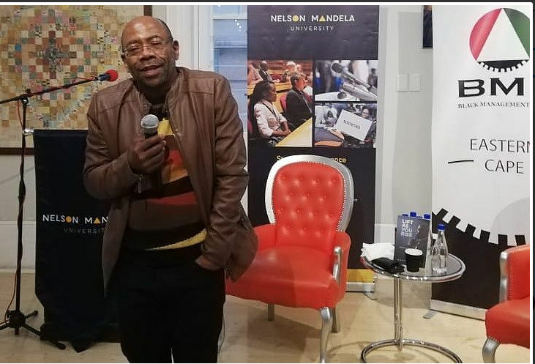
"Leadership is about being obsessed with the development of others. It is about realising it is not about me." This is what Bonang Mohale, former CEO of Business Leadership SA (BLSA), had to say about the traits of a good leader. Mohale, who was in Nelson Mandela Bay on Thursday to launch his book Lift as You Rise, spoke about the experiences that shaped his life. “If you succeed in pleasing the other, it comes back tenfold. “Management is about getting things done through other people, but leadership is different. "It says I'm happy that I've made my contribution, I want to celebrate my people and being genuinely happy with the success of others."
One of the prominent themes of the book is the role that business can play in SA by claiming its space in society. Mohale refers to the “business believes” initiative in which BLSA’s members have committed to a contract with SA to create jobs by growing the economy; empowering and encouraging senior black leadership; investing in South Africans and communities; supporting small businesses; and condemning and rooting out corruption.

Speaking on the recession, Mohale said everything that has contributed to SA’s woes was self-made and self-inflicted. “Now we celebrate that we’ve dodged a technical recession, yet you and I know that we’ve been in recession for a number of years because we are collectively poorer now than we were years ago. “We are hanging by the teeth of our nails to an investment grade by the three ratings agencies. Only Moody’s has kept us above investment grade.
“Had they downgraded us, R100bn would have been out because those asset managers don’t have the discretion, they cannot invest in institutions or countries that are below investment grade. It happens automatically. “Incidentally, it’s the same target that President Cyril Ramaphosa has set out for us through the four investment envoys over five years,” Mohale said. To emphasise his point, Mohale said had Moody’s downgraded SA, the rand would have been hammered, the Reserve Bank would have been forced to increase the repo rate to protect the currency and to keep inflation in check. “When you do that, the cost of borrowing from government goes up, you pay more for your bond and your car and all of us become poorer had it happened,” he said.

Mohale also spoke on the potential the tourism sector could play towards the country’s GDP, which at present is contributing only 9%. “We’re the only country in the world where we can look tourists in the eyes and tell when whatever you need, we’ve got it. Yet tourism only contributes 9% instead of 20%,” he said. Speaking on the civil unrest in the country, Mohale said lawlessness had become an epidemic, that the inequality gap was widening, and that racism was at an all-time high.
Source: Businessman Bonang Mohale talks on how to be a good leader (heraldlive.co.za)

- Define the term leadership. (3)
- Quoting from the case study, show how this businessman is more of a leader than a manager.
(4)
- According to the case study, Management and Leadership are different, briefly discuss this difference as set out in the case study. (8)
- This businessman is quoted as saying “Leadership is about being obsessed with the development of others, briefly discuss the leadership tools (as explained by Erasmus, Strydom and Rudansky-Klopper) which he may have used to achieve this goal. (2x5)

Total [100]

