

EXAMINATION: | OCTOBER/NOVEMBER | PROGRAMME | BED INTERMEDIATE PHASE
MODULE CODE: | EMPT51012 | DURATION: | 3 Hours
MODULE DESCRIPTION: | MATHEMATICS FOR PRIMARY TEACHERS | MARKS: | 100
EXAMINER(S): | Dr C. CHIKIWA | DATE: | 30 OCTOBER 2023
MODERATOR(S): | Dr E. MATABANE | TIME: | 14:00-17:00

Instructions
- The examination paper is divided into Sections A, B and C.
- Please answer all the questions in all sections.
- Show all your working clearly and legibly.
- Marks for each question are shown in brackets.
- Answer Sections A and B on the two grids provided. Remember to place your two grids in the answer book.
- In Section C, all calculations must be detailed and clearly shown in the answer book.

SECTION A [1 mark x 10 items = 10 marks]
State whether each of the following is true (T) or false (F). (Write either T or F in the answer grid provided)
STATEMENT | TRUE | FALSE
- Every irrational number is a real number.
- If a number in scientific notation has a negative exponent, then the number is negative.
- When a number in decimal notation is larger than 1, the exponent of 10 in scientific notation is positive
- $\frac{6^{2}}{{36}^{2}}= \frac{1}{3}$when simplified
- The sum of the exterior angles of a polygon is 360°.
- An obtuse triangle can also be an isosceles or a scalene triangle.
- All squares are rectangles but not all rectangles are squares.
- A trapezoid is also a parallelogram.
- The bisectors of all three interior angles intersect inside a triangle at a point
- When all points in space are coplanar, the geometry is two-dimensional (2D).
[10 marks]

SECTION B [1 mark per question = 20 marks]
In each of the following, choose the correct answer and indicate it on the answer grid provided.
- Put these numbers in order from least to greatest.
α. 8.75
β. 8.00
γ. 8.44
δ. 8.04
- α, γ, δ, β B. α, β, δ, γ C. β, δ, γ, α D. δ, β, γ, α E. None of the above

- Write in standard notation. (6 x 1000) + (4 x 10) + (3 x 1)
- 6,034 B. 6,340 C. 6,430 D. 6,043 E. None of the above

- Evaluate $\frac{2}{3}-\frac{4}{9}=$
- $\frac{2}{9}$ B. $\frac{1}{3}$ C. $\frac{2}{6}$ D. $\frac{4}{9}$ E. $None of the above$

- Divide $7.68 by 0.64 leaving your answer to the nearest tenth.$

- $1.2$ B. $4.9$ C. $12.0$ D. $49.0$ E. $None of the above$

- Which of the following statements is not true?
- Both addition and multiplication are associative for whole numbers.
- Zero is the identity for multiplication of whole numbers.
- Addition and multiplication both are commutative for whole numbers.
- Multiplication is distributive over addition for whole numbers.
- All the above.

- The decimal representation of a rational number is
- always terminating
- either terminating or repeating
- either terminating or non-repeating
- neither terminating nor repeating
- always repeating and non-terminating

- Which of the following statements is not true?
- 0 + 0 = 0 B. 0 – 0 = 0 C. 0 × 0 = 0 D. 0 ÷ 0 = 0 E. All the above

- What is 0.000058 written in scientific notation?
- $5.8×{10}^{-6}$
- $5.8×{10}^{-5}$
- $5.8×{10}^{5}$
- $5.8×{10}^{6}$
- $None of the above$

- $Evaluate 2.5×{10}^{4}-1.5×{10}^{3}=$
- $1×{10}^{1}$
- $1×{10}^{7}$
- $2.35×{10}^{7}$
- $2.35×{10}^{4}$
- $None of the above$

- A rectangular section of wilderness will be set aside as a new wildlife refuge. Its dimensions are $5×{10}^{5} meters$ by $4×{10}^{4} meters$. Find the area of the land in square meters.

- $9×{10}^{1}$ B. $9×{10}^{9}$C. $2×{10}^{10}$D. $20×{10}^{9}$ E. $None of the above$

- Look at the pattern.

Which set of letters best represents the pattern?
- AB B. ABB C. ABC D. ABCD E. None of the above.

- Continue the pattern.

↑↓↑↓↓…….

- ↑↓↓↓
- ↑↑↓↓
- ↓↓↓↑
- ↓↓↓↓
- None of the above.

- The teacher wrote the following numerical pattern on the board:

5, 11, 17, 23, 29
The teacher then asked the students to write a similar pattern. Which set of numbers follows the teacher's pattern?
- 2, 4, 6, 8, 10
- 3, 6, 9, 12, 15
- 2, 8, 14, 20, 26
- 1, 4, 7, 10, 13
- None of the above

- Which statement about the third corresponding terms in both Pattern X and Pattern Y is true?
Pattern X: start at 10 and add 5
Pattern Y: start at 10 and add 10
- Both number values will be 20.
- Both number values will be less than 20.
- Both number values will be greater than 20.
- The Y value will be 20 and the X value will be more than 20.
- The X value will be 20 and the Y value will be more than 20.

- A number pattern is shown below.
1 2 2 3 1 2 2 3
Which group of words represents the pattern shown above?
- blue, green, blue, red, blue, green, blue, red
- green, blue, blue, green, green, blue, blue, green
- blue, green, green, red, blue, green, green, red
- green, blue, green, red, green, blue, green, red
- None of the above

- Dale created the following pattern.
0.2, −0.6, 1.8, −5.4, …
The pattern continues. What is the next number in the pattern?
- −16.2 B. −10.8 C. 10.8 D. 16.2 E. None of the above.

- Vutomi set up a lemonade stand at a local park. He sold 10 cups of lemonade on the first day, 15 cups on the second day, 17 cups on the third day, 22 cups on the fourth day, and 24 cups on the fifth day. If this trend continues, how many cups of lemonade can he expect to sell on the ninth day?

- 36 B. 38 C. 29 D. 43 E. None of the above.

- A diagram of Mpho’s living room wall with a geometric design that she painted is shown.
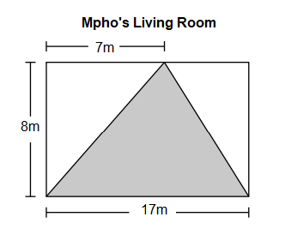
What is the area, in square metres, of the unshaded part of Mpho’s design?
A 51
B 56
C 68
D 119
E 136

- Which solid figure would this net make?
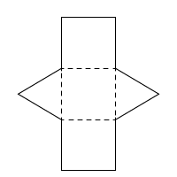
- Cuboid
- cone
- pyramid
- triangular prism
- rectangular prism

- A cylindrical container of radius 70 cm is 200 cm deep. The container is filled with water to a depth of 140 cm. What is the volume of water, in cubic metres, needed to fill the remaining part of the container?

A. 0.0264 $m^{3}$ B. 0.924 $m^{3}$ C. 1.960 $m^{3}$ D. 2.156 $m^{3}$ E. 3.08 $m^{3}$

SECTION C [45 marks]
- Write each number in scientific form.
- 60 001 005 [1]
- 0,000 073
[1]

- Write $\frac{48}{100}$in Decimal Form. [2]
- Write $\frac{1}{13}$ in Percentage Form. [2]

- Express $0,2\overline{7}$ in the form$\frac{p}{q} , where p and q are integers and q≠0.$ [3]

- a. Tebogo collected 200 fruits from his orchard. 56 of the fruits were durians and the rest were mangoes. What percentage of the fruits were mangoes? [3]
b. There are 500 tickets for a concert. 90% of the tickets were sold. 60% of the tickets sold were adult tickets and the rest sold were children’s tickets.
- How many tickets for adults were sold? [2]

- How many tickets for children were sold? [2]

- Express $\frac{1.5 ×{10}^{3}}{4.5×{10}^{-4}}$ in the standard form. [3]

- Evaluate each of the following:

- Simplify $4.2×{10}^{6}-2.25×{10}^{4}+2.8×{10}^{6}$ leaving your answer in scientific form [3]

- Evaluate $\frac{8.4×{10}^{-3}}{(5×{10}^{2})(1.2×{10}^{6})}$ , leave your solution in scientific form. [3]

- Using the lattice method, find 387×45= [3]

- The distance from between the Sun and the Earth is $1.488×{10}^{8} km$ and the distance between the Earth and the Moon $4.62×{10}^{8}m.$ During the solar eclipse the Moon comes between the Earth and the Sun. What is the distance between the moon and the Sun at that time when there is a solar eclipse? [3]
- Sheep enclosures are built using fences and posts. The enclosures are always built in a row.
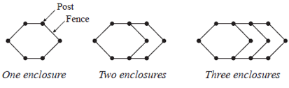
  - State the number of posts and that of fences when you have five enclosures in a row. [2]

  - Hence complete the table below 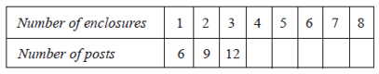
[2]

  - Find an expression for the number of posts needed for $n$ enclosures in a row.
[3]
  - Calculate the number of posts needed for 30 enclosures in a row. [2]
  - How many enclosures in a row will be made from 57 posts? [2]

- Calculate the size of angle $x in each case.$

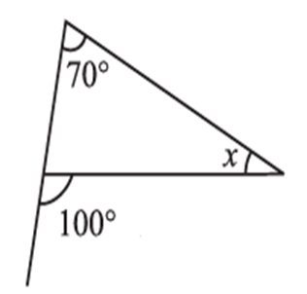 [3]
ii.
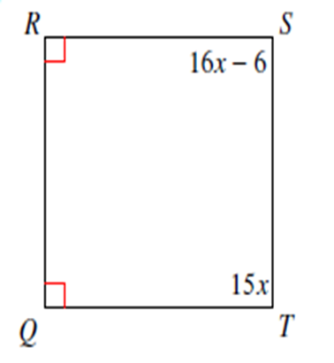
[3]
- Two sides of a triangle have the following measures: 5cm and 8cm. Find the range of possible measures for the third side. [3]

- Find the perimeter of the following shaded compound shape. Each small square block equals 1 cm.
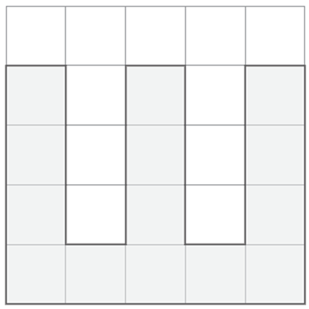
[2]
- Given that each small square block equals 1 cm by 1cm. Find the ratio of the shaded area to that of the unshaded in compound shape below.
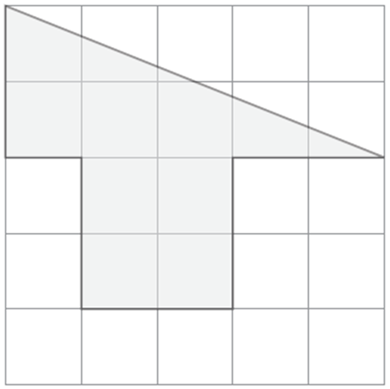
[4]

- Find the measure of one exterior angle in the regular polygon below. Round your answer to the nearest tenth if necessary.

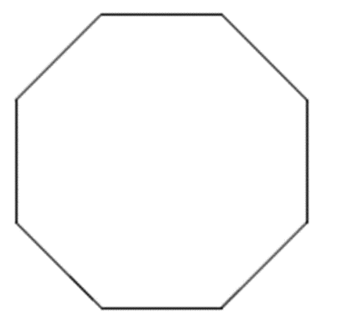
[3]

- Is there a regular polygon with an interior angle sum of 9000°? If so, what is it? [3]

- A kidney-shaped swimming pool has surface area 15 $m^{2}$ and a constant depth of 2 meters. Find the capacity of the pool in kilolitres. [3]
- A water trough has triangular cross-section as shown in the diagram below. Its length is 2 m.
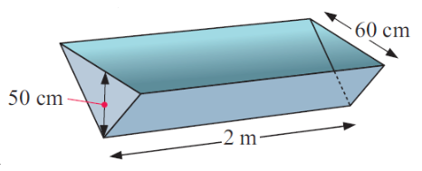
Find:
a) the area of the triangle in cm² [2]
b) the volume of space in the trough in cm³ [2]
c) the capacity of the trough in:
i) litres [2]
ii) kilolitres. [1]

End of Examination Paper

ANSWER GRID FOR SECTION A
STATEMENT | TRUE | FALSE

ANSWER GRID FOR SECTION B

