

Requirements for this paper – indicate with an X

 | Multiple-choice cards: |  |  | Non-programmable calculator: | x |  |  |  | Open book examination?
 | Graph paper: |  |  | Laptop:
EXAMINATION: | Main Year-End Examination | PROGRAMME: | B.Ed. 3 (Intermediate Phase)
MODULE CODE: | EMST63024 | DURATION | 3 hours
MODULE DESCRIPTION | Mathematics Teaching 1 | MARKS | 100
EXAMINER | Mr. J Thomas | DATE | November 2023
MODERATOR(S): | Prof. P Sepeng (internal – SPU)  Dr. Tachie (external – UL) | TIME: | 08:00 – 11:00

INSTRUCTIONS:
- Answer all questions.
- Be as explicit as possible.
- You may use a clean copy of your CAPS document.

QUESTION 1 [30]
1.1 The Venn diagramme below, refers to the interaction of four knowledge types which are essential for effective teaching. Explain the importance of the overlapping areas indicated by 1.1, 1.2 and 1.3 for the effective teaching of Whole numbers.
PCK-1.3
Content
Content knowledge
1.1
Pedagogical knowledge
1.2 Pedagogical knowledge
(3 x 2 = 6)

1.2 The following five schools of thought on the philosophy of mathematics were well known, and Ernest (1985:611) discussed them to understand the relationship between them and issues in mathematics education. Logicism (pure mathematics is part of logic), formalism (mathematics is an insignificant game played by marking on paper according to a rule), platonism (the object of mathematics is an objective existence in a certain ideal domain), constructivism (the meaning of a mathematical object is made up of the process by which it is constructed) and Falliblism (mathematics is what mathematicians do and have done) provide a view of the nature of mathematics. Clearly indicate how these contrasting beliefs about the nature of mathematics, namely, Platonism and constructivism could influence the teacher when teaching congruency of triangles. (10)

A
D

C
B
F
E

1.3. Given the extract from the CAPS document:
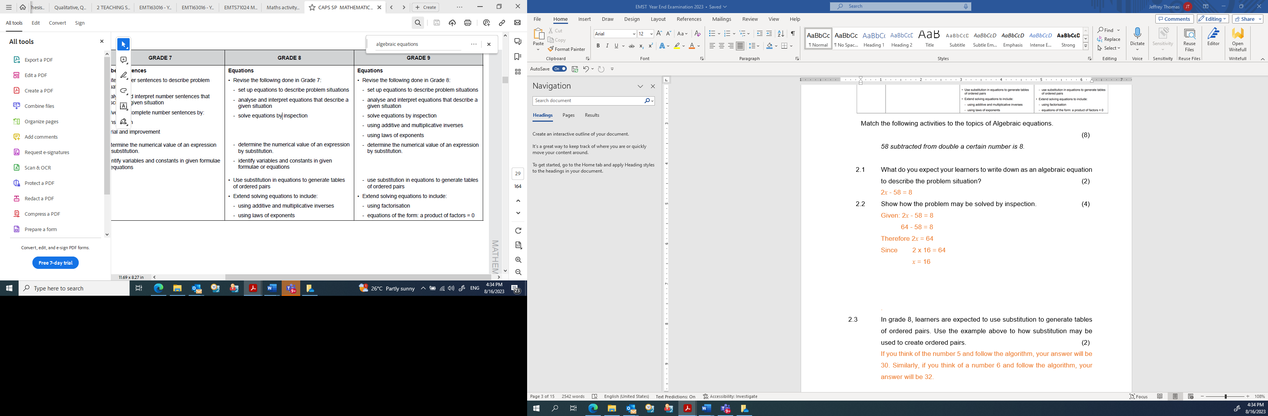
(DBE, 2011:25)
Answer the following questions based on the topic, Algebraic equations, as expressed in the extract from CAPS.
The teacher writes the following on the board for the grade 8 learners to engage.
58 subtracted from double a certain number is 8.

1.3.1 What do you expect your learners to write down as an algebraic equation to describe the problem situation? (2)

    - Show how the problem may be solved by inspection. (4)

1.3.3 In grade 8, learners are expected to use substitution to generate tables of ordered pairs. Use the example above (or your own) to show substitution may be used to create ordered pairs. (4)

1.4 The chart represents the Roman numerals vs. the Hindu-Arabic numerals from 1 to 10.
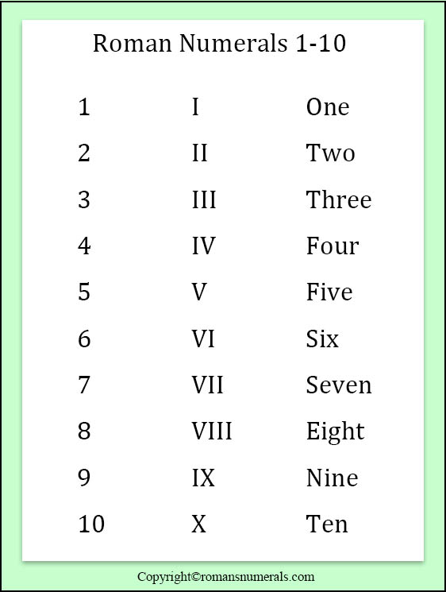
The symbols may be combined to form numbers less than 50.
    - Study the chart and write down how the number 29 will be presented in Roman numerals. (2)

    - Show how you can use these Roman numerals to develop recognition that Mathematics is a creative part of human activity. Refer to the structure of the number system or the comparison between the Roman numerals and the Hindu-Arabic number systems. (2)

QUESTION 2 [40]

2.1 Consider the extract from CAPS (2011:29) and answer the following questions. Discuss the progression, if any, in content as the topic of transformation is taught to learners in grade 7, 8 and 9. Provide suitable examples to illustrate your point. (10)
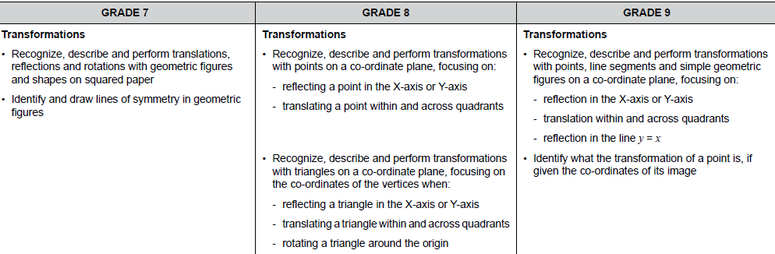

2.2 The teacher prepares a lesson on 2D-shapes where the solving of geometric problems involving unknown sides and angles are concerned. She provided them with the following problem to solve.
Use your knowledge of triangles to determine the angles of the quadrilateral ABCD. Write down the value of $∠$A + $∠$B + $∠$C + $∠$D.
49º
B
A
x
z

y
100º
49º
D
C

2.2.1 Explain what is the most likely new knowledge that the teacher expects the learners to learn. (2)

2.2.2 Explain what prior knowledge the learners should have to be able to master the new content. (4)

2.2.3 Suppose that a learner is not able to determine the correct value of x:

2.2.3.1 What is the most likely prior knowledge that is missing. (2)

2.2.3.2 Explain with illustrations how you would practically assist that learner to be able to find the correct value? (6)

2.3 When problem solving is used as a teaching technique, it may be applied as either teaching through, for or about problem solving (Killen; 2015: 260). The teacher wants to use Polya’s Problem Solving Model to teach learners how to solve problems. (10)
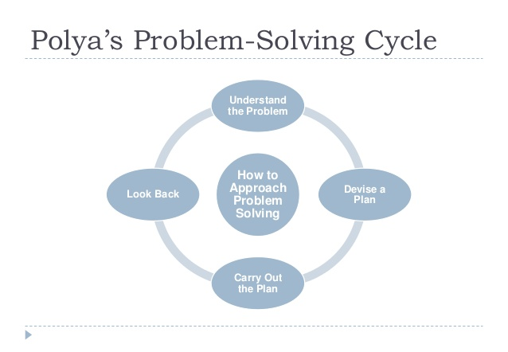

Explain through Problem Solving how the problem, below should be tackled.

How many triangles are there in this figure?

2.4. Jacobs, Vakalisa & Gawe (2011: 220) proposes that learners should experience learning from the concrete to the iconic and finally to the abstract. Provide diagrams to illustrate how the three experiences (the use of media) will be utilized in the scenario described below to conceptualise the mathematical concept of Probability. Provide with explanations on how to interpret your diagrammes:
(3 x 2 = 6)

Sipho decides to toss a coin 50 times. In each toss he will note the outcome (Head or Tail). Approximately how many times do you think he will note each of the outcomes?
Head
Tail
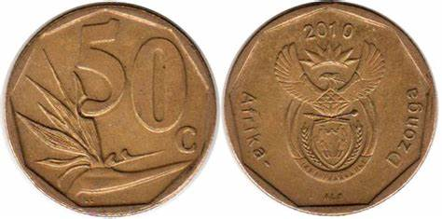

QUESTION 3 [24]
3.1 The objectives of a lesson plan describe what learners are expected to do as a result of the teacher’s instruction. Align each of the objectives listed in questions 3.1.1. – 3.1.6. to the different levels (remember, understand, apply, analyse, evaluate & create) of Bloom's taxonomy. (6x2)

3.1.1 Plan a report to motivate based on collected data on how the school should implement sports in the school.

3.1.2 Define probability.

3.1.3 Use the given data set to calculate the five-point summary.

3.1.4 From the bar graph, determine the most popular sports type.

3.1.5 Determine what prior knowledge is most relevant in order to solve the algebraic equations.

3.1.6 You are hurriedly requested to determine the most popular type of transport to the school, and you have the option to use either an online or physical questionnaire. Determine which one is, from your perspective, will be the most effective.

3.2 The constructivist view of learning requires a shift from the traditional approach of direct teaching to facilitation of learning by the teacher. The teacher believed in the constructivist philosophy and presented a lesson on solving problems on area of polygons to the grade 8 learners. Using the template below, indicate how you would facilitate a lesson based on the constructivist philosophy where the grade 8 learners engage in calculating the area of a square using a formula as per the extract from the Curriculum Assessment Policy Statement document for the Senior Phase. (12)

Present your answer as per the template below:
What the teacher says | What is on the board or provided to the learners | What the learners do

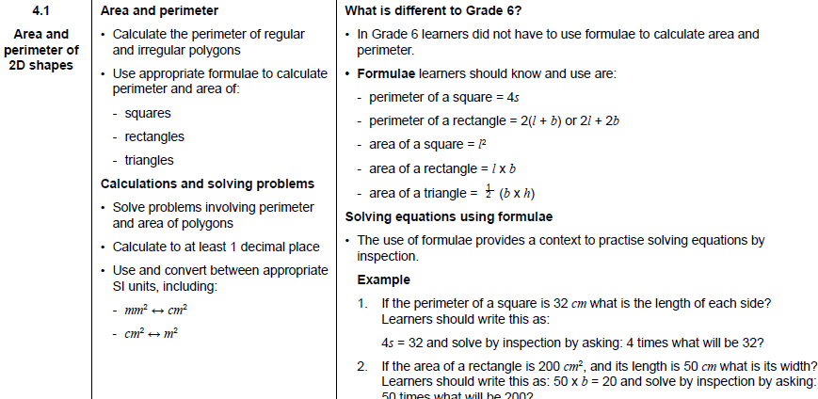
DoE (2011:55)

Your answer will be assessed according to this rubric.

Criteria | Incompetent (0-1) | Developing competence (2) | Competent (3)
Link to prior knowledge | No recollection of Prior knowledge. | Limited recollection of relevant prior knowledge. | Recollection of all relevant prior knowledge.
Contextual problem | Irrelevant contextual problem provided. | Relevant contextual problem provided with minor misconceptions. | Relevant contextual problem provided.
Learner action to construct knowledge | Learner actions are not consistent with constructing new knowledge. | Learner actions partially consistent with constructing knowledge. | Learner actions fully consistent with constructing knowledge.
Content | Inconsistent application of CAPS. | Partially consistent application of CAPS. | Consistent application of CAPS.

QUESTION 4 [6]
4.1 Boston (2002) believes that formative assessment should be used to adapt
teaching and learning. Consider the following formative assessment activity.
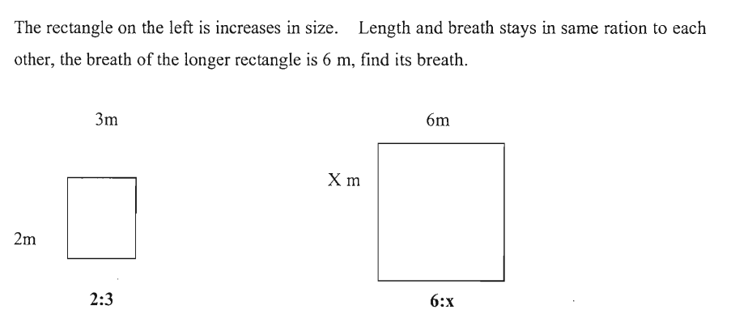
4.1.1 What is the most probable aim of this formative assessment activity? (2)
4.2.2 Are the instructions clear and comprehensive? (2)

4.3 Feedback provided on assessed work should assist learners to become aware of any gaps that exist between their desired goals and their current knowledge and skills. Write down your feedback to the learner who responded as follows to the question. (2)
Since: 2:3
Given: 6:x
It is wrong it should be x:6 and therefore the answer is 4:6. x = 4.

[TOTAL: 100]

